Assignment # 8

May 2021

1)

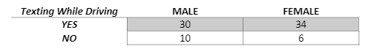

Male (Yes) = 30/40 or 3:1 odds

Female (Yes) = 34:40 or 5.667:1 odds

Male to Female (Yes) = 30/64 or .883:1 odds

Female to Male (Yes) = 34/64 or 1.132:1 odds

2)

a)

There are 80 students of 626 total students who attended a religious school. The probability of attending a religious school as .146 to 1.

b)

Probabilities:

White attending private school = .121

Non-white student attending private school = 0.415

Odds:

White attending private school = .138 to 1

Non-white student attending private school = 0.043 to 1

Odds Ratio (95% CI) = .34

c)

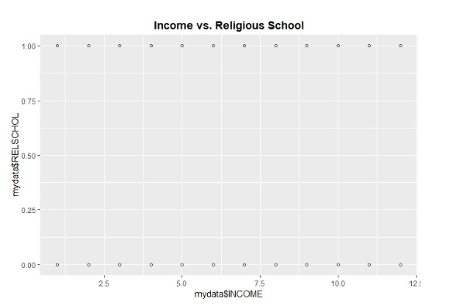

The scatterplot showing religious schools and income did not have enough relevant data to show anything on the plot. It also doesn’t show any differences between religious and non-religious schools.

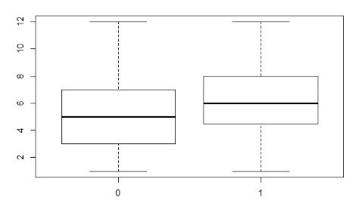

The datasets are separated at the 5-levl income bracket and thus we will create two separate sets of values at the key level.

Cross-tabulation results:

Probabilities:

Low income students attending private school = .097

High income students attending private school = .032

Odds:

Low income students attending private school = .107 to 1

High income students attending private school = .033 to 1

Odds Ratio (95% CI) = .41

d)

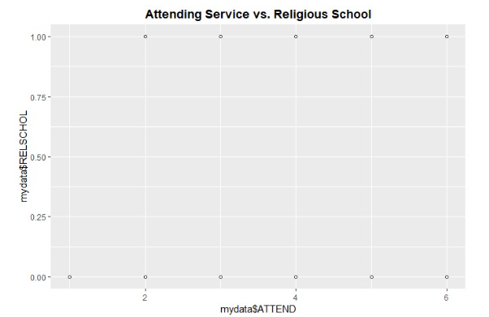

The plot again shows there are no individuals who attend a religious service less than 2 times per month that attend a private school.

Cross-tabulation results:

Probabilities:

1 service per month attending private school = 0

2 service per month attending private school = .006

3 service per month attending private school = .006

4 service per month attending private school = .014

5 service per month attending private school = .085

6 service per month attending private school = .016

Odds:

1 service per month attending private school = 0 to 1

2 service per month attending private school = .006 to 1

3 service per month attending private school = .006 to 1

4 service per month attending private school = .014 to 1

5 service per month attending private school = .093 to 1

6 service per month attending private school = .016 to 1

The results show the attending 5 services a month is the highest indicator of attending a private school. The data peaks at 5 and then begins to drop down, at least for attending 6 services which is an interesting note from the data.

3)

Model 1 = -1.073 – 1.091X1

a) Interpretation = n1 = .1623 is the change in log odds ratio for a 1 unit change in x1 = income

b) For each additional income bracket, odds of attending private religious school increases by 17.621%

c) AIC = 467.4662

d) BIC = 476.3449

4)

Model 2 = -2.8211 + .1623X2

a) Interpretation = b1 = .1623 is the change in log odds ratio for a 1 unit change in x1 = income

b) For each additional income bracket, odds of attending private religious school increases by 17.621%

c) AIC = 445.322

d) BIC = 454.084

e) The lower aic and bic values show a better fit for predicting if an individual attended a religious private school rather than race. The model is also easier to interpret and makes more logical sense.

No values of X seems to exceed the .50 threshold which seems to make sense as income alone is not a good indicator for whether a student attends private religious school or not.

5)

Model 3 = -2.9727 + .2269X3

a) Interpretation = b1 = .2269 is the change in log odds ratio for a 1 unit change in x1 = attend

b) For each additional income bracket, odds of attending private religious school increases by 25.47%

c) AIC = 478.504

d) BIC = 487.382

e) The results show that this model is not as good a fit as model 1 and 2 despite its easier interpretability.

No value of X seems to exceed the .50 threshold and it makes logical sense that religious attendance alone is not a good indicator for whether a student attend private religious school or not.

6)

Model 4 = -23.5831 + .3316X1 + .2007X2 – 1.2893X3

a) Interpretation = b1 = .3316 is the change in log odds ratio for a 1 unit change in x1 = attend; b2 = .2007 is the change in log odds ratio for a 1 unit change in x2 = Income; b3 = -1.2893 is the change in log odds ratio for a 1 unit change in x3 = race

b) For each additional day per month an individual attends religious services, odds of attending private religious school increases by 39.319%; For each additional change in income bracket the odds an individual attending private religious school decreases by 22.226%; For each additional change in income bracket the odds an individual attending private religious school decreases by 22.226%; For white individuals the chances of them attending a private religious school decreases by 72.45%

c) AIC = 424.793

d) BIC = 442.313

e) This model compares the most favorably which makes sense as each variable combine to prove a better prediction on if an individual attends private school or not. The model becomes more complicated as we add more variables and will have to play out with further models.

White = -3.583 + (.3316 \*5) + (.2007 \* 4) + (-1.2893\*1) = -2.4116; Odds = .090 to 1

Non-white = -3.583 (.3316\*5) + (.2007 \* 4) + (-1.2893\*0 = -1.1223); Odds = .325 to 1

The odds ratio is .115, and because this value is much lower than 1, we can say the odds of prediction if an individual attends a private religious school based on race is low.

7)

Model 1 = -1.073 – 1.091

a) P! = exp(Model 1)/(1+exp(Model 1))

b) Using this formula, none of the P! levels are greater than .50 so each predicted value s 0

Model 2 = -2.8211 + .1623

a) P! = exp(Model 2)/(1+exp(Model 2))

b) Using this formula, none of the P! levels are greater than .50 so each predicted value s 0

Model 3 = -2.9727 + .2269

a) P! = exp(Model 3)/(1+exp(Model ))

b) Using this formula, none of the P! levels are greater than .50 so each predicted value s 0

None of these models produce correct classifications for students whit attend religious schools

8)

After reviewing the results, there does not seem ot be a very strong relationship between a student’s race, religious service attendance, family income, and religious school. Other outside factors seem to play a more prominent role in the correlation. Income bracket, for example, was a good measure of private school attendance which made logical sense due to the cost and regard placed on private schools. Race did not seem to have a noticeable enough correlation to attending a religious school. Increasing from a zero to one decreased the percent change of attending a private school, and look forward to building more models to gain better results.